**Final Report The battle of neighbourhoods**

# Introduction

Toronto is itself a cultural phenomenon, with residents from around the world and scores of languages, foods, customs and cultures. Toronto is the largest city in Canada and the 4th largest city in North America, with a population of 6.2 Million people as of 2020 (a 0.94% increase from 2019). The total population in Greater Toronto Area and the outskirts is 9.25 Million, meaning that Greater Toronto Area makes up 67% of the total population of the area, with the city growing at an ever-increasing rate. Around 48% of Toronto’s population is made up of those who are of an ethnic minority.

As the area is known to be very diverse, many areas would have developed differently, due to industrialisation or cultural changes due to masses of people from one ethnicity into the area. Toronto has a very high Chinese and South Asian population; this may create areas which can be clustered due to similar activities being offered.

# Problem:

1. List the top 100 venues Toronto and plot it on a map.

2. What neighbourhoods have similar venues.

3. Where do the most neighbourhoods with similar venues lie.

# Data Section:

The Demographics show Toronto’s very ethnically diverse cosmopolis, with large Chinese and Indian cultural influence. Does this influence create clusters based on locations or are these venues spread evenly around Toronto?

## Data for this Project:

• Toronto data, containing neighbourhoods and its coordinates.

o Data sources being used: https://en.wikipedia.org/w/index.php?title=List_of_postal_codes_of_Canada:_M&oldid=857830462 and http://cocl.us/Geospatial_data

o Description: This Data Source provides all the required information in order to explore the neighbourhoods of Toronto

• Top 100 venues within a 1km radius in each neighbourhood of Toronto

o Data Source: Foursquare API

o Description: This API will allow me to find all the venues around the neighbourhoods, using a filter to search withing a 1000m radius.

• Geospace Data

o Data Source: https://open.toronto.ca/dataset/neighbourhoods/

o Description: Using this data we can visualize the neighbourhood boundaries on the map using a choropleth map

# Methodology

1. We begin by collecting the Toronto data from the following link: <https://en.wikipedia.org/w/index.php?title=List_of_postal_codes_of_Canada:_M&oldid=857830462>
2. 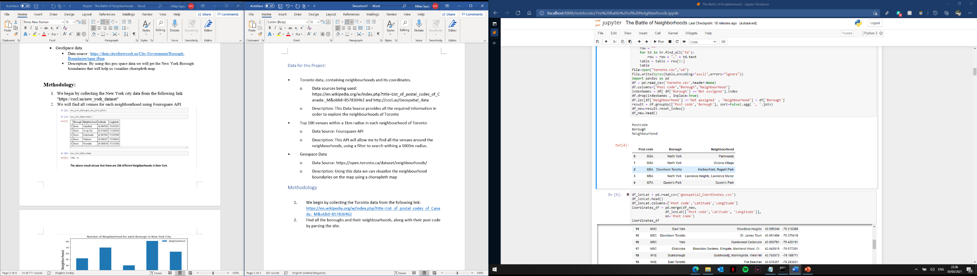Find all the boroughs and their neighbourhoods, along with their post code by parsing the site.
3. 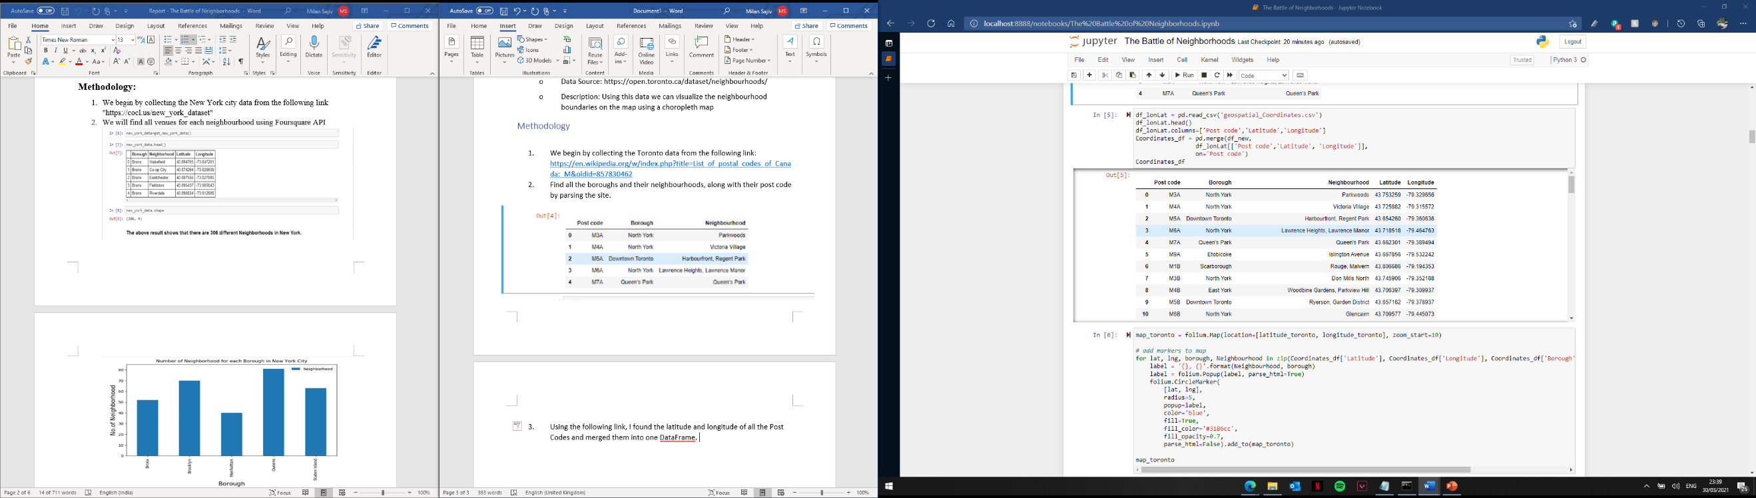Using the following link, I found the latitude and longitude of all the Post Codes and merged them into one DataFrame.
4. Visualise these locations by using python’s Folium library.

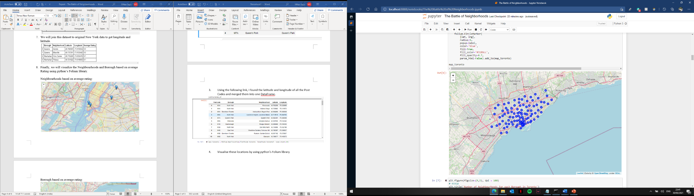

1. 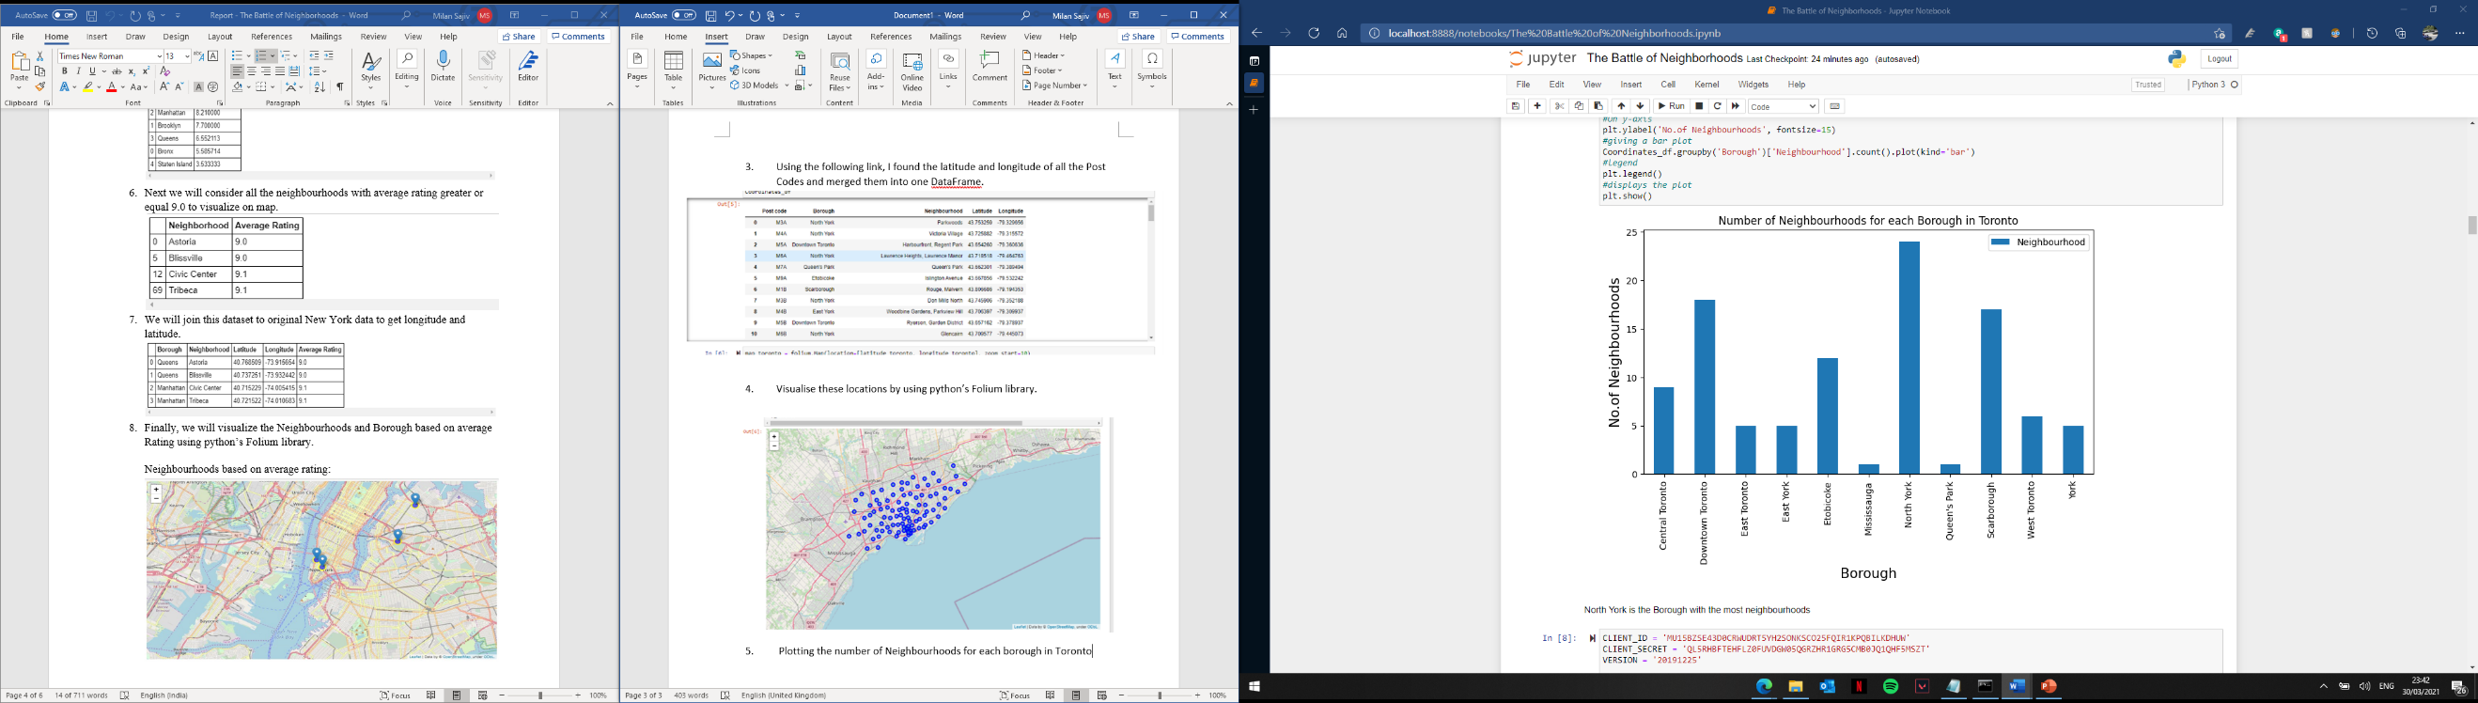 Plotting the number of Neighbourhoods for each borough in Toronto
2. 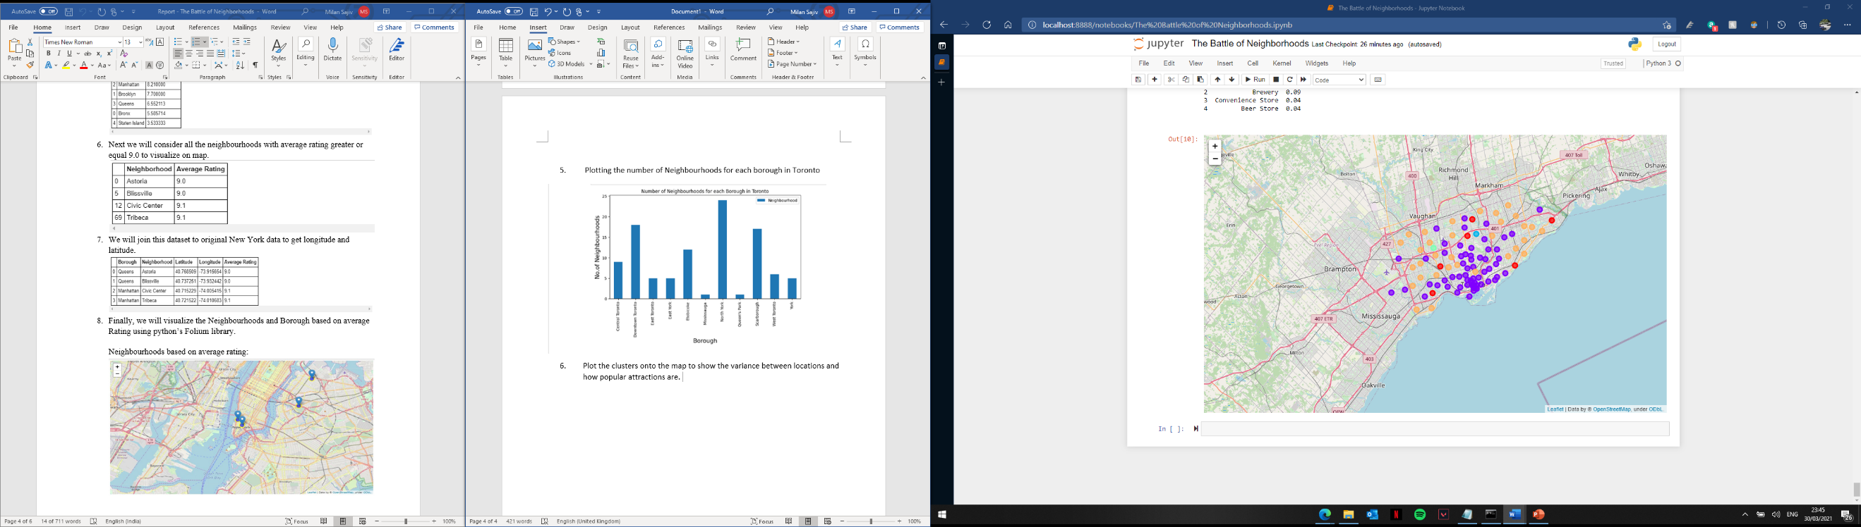Plot the clusters onto the map to show the variance between locations and how popular attractions are.

# Results/Conclusion:

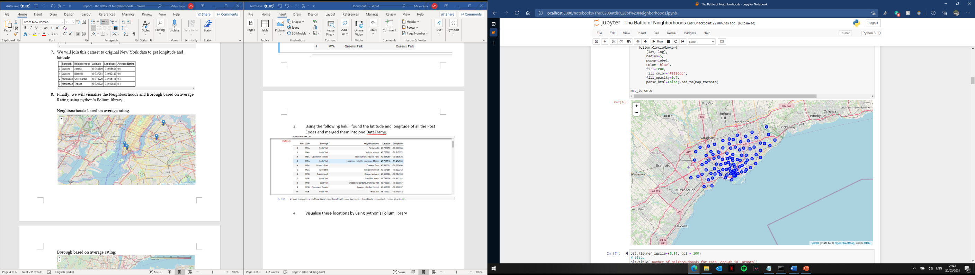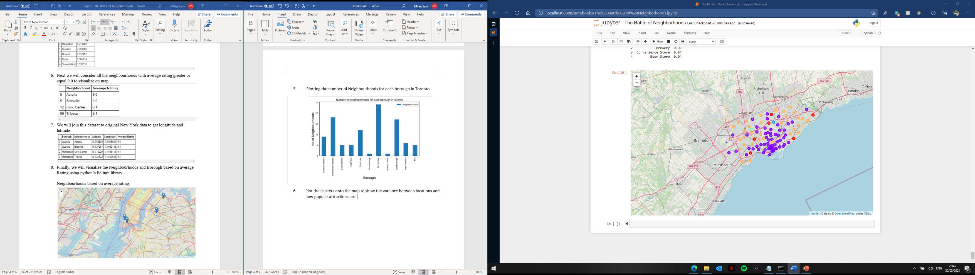

As we can see there is a major difference in clusters the further from the lock of water you travel, the centre of all the neighbourhoods in the centre of Toronto however are all very similar in characteristics, and as you travel the further away from the centre the wider range of option’s you end up getting. Although there are less neighbourhoods that are close together.